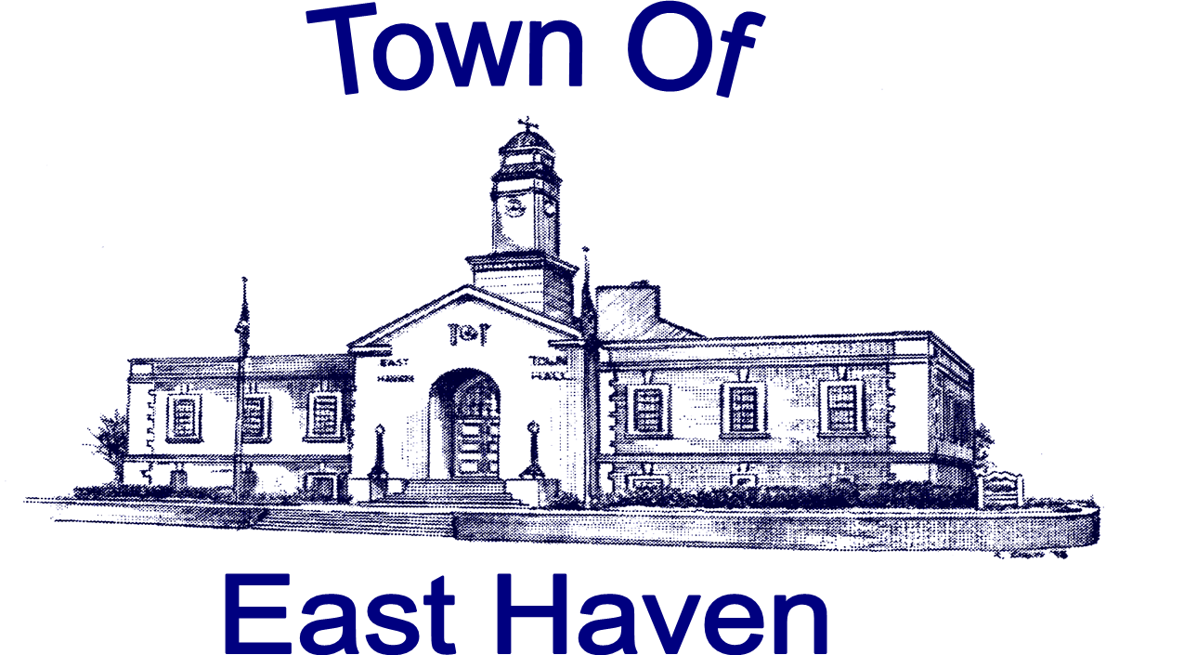
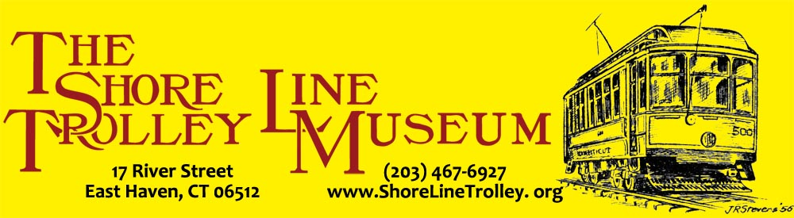
World Trade Center surviving PATH Subway Car arriving at The Shore Line Trolley Museum, East Haven - Thursday, August 6th 11:15 AM
The Shore Line Trolley Museum has announced that they have reached an agreement with The Port Authority to receive PATH Car 745, which was in the PATH station under the North Tower of the World Trade Center and survived the 9/11 attack. The museum and East Haven Mayor Joseph Maturo, Jr. will be receiving the car on Thursday August 6th at 11:15 a.m., as it arrives at its location on River Street in East Haven. The vehicle will be given traditional Bagpipe Parade with a Police and Fire escort from the corner of River and Hemingway Avenue down to the location of the Trolley Museum at 17 River Street. The short route is expected to be lined with emergency service personnel from the East Haven and Branford along with other area departments. Following the procession, a brief speaking program will be held at the entrance of the museum, which in addition to Mayor Maturo and the officials of The Shore Line Trolley Museum is expected to be attended by Branford First Selectman James Cosgrove, local State Legislators and representatives of PATH. Other first responders and the public are also invited to attend.
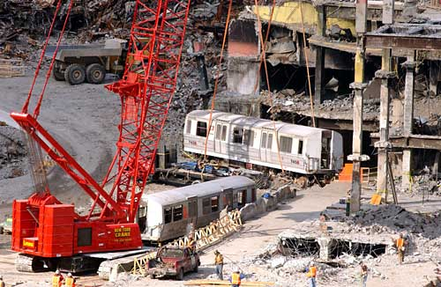
The car which is being donated is one of two that were found in a cast iron tunnel which enabled them to withstand the pressures from the collapsing buildings above. On the morning of 9/11 it was sent to the World Trade Center to pick up passengers, but none were found inside when the car was discovered during excavation. The car, which since that time was housed in an airplane hangar at JFK Airport, is still in the original condition as when removed from the tunnel. It was to be included in the 9/11 Museum but was determined to be too big.
Once the car arrives, a permanent display will be created and dedicated next year, which will include original WTC station signage and pieces of the tunnel itself for all to see as a remembrance of the day that changed this nation like no other.
(Also included is a photo of the car as it is being warehoused in the hangar at JFK Airport)
For further info contact Event Coordinator: Wayne Sandford: Info@shorelinetrolley.org tel: 203-804-8364

